Local LLM (Offline AI) — Ek Standard Guide (Hinglish)

1. Introduction aur Definition
Local LLM = aisa Large Language Model jo internet pe depend na kare aur aapke machine/server par hi chale (offline mode).
Benefits: Data privacy, low latency, offline use, aur pura control aapke paas.

2. Model Versions / Types
- Chhote / Mid-size models (1B–13B parameters) – Laptop/consumer GPU pe run karne layak. (e.g., GPT4All models)
- Large models (30B–70B) – 48GB+ VRAM ya multi-GPU setup required.
- Very Large models (100B+) – Datacenter level GPUs (A100/H100) chahiye.
- Optimized On-device builds (Apple M-series, AMD Ryzen AI) – CPU / M-series chips pe bhi chalne wale optimized runtime available.

3. Hardware Suggestions (GPU / CPU)

A. Consumer-level (Personal Use / Prototype)
- Example: NVIDIA RTX 4080 / 4090
- Achhi VRAM aur compute power ke saath 7B–13B models easily run ho jate hain.
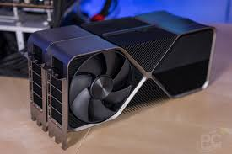
Cost Jayda mehaneg hai buy iski 1.25 lakh something but perofrmace is too good

B. Pro / Server-level (Bigger Models ke liye)
- Example: NVIDIA A6000, L40, RTX 6000 (48GB–80GB VRAM)
- 30B–70B models ke liye suitable, fine-tuning bhi ho sakti hai.

C. Data-center GPUs (Production / Enterprise)
- Example: NVIDIA A100 / H100
- 100B+ models ya large-scale serving ke liye best option.

Note on CPU / Apple Silicon
- Apple M-series (M1/M2/M3) aur AMD Ryzen AI chips small/mid models ke liye kaafi optimized hai.
AMD Radeon RX 550
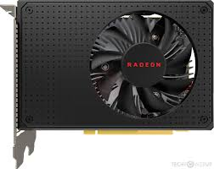
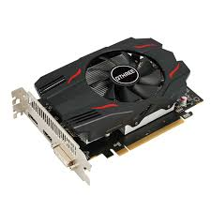
this cost is 6000 – 8000 smart but slow response gpu

4 Tools & Frameworks (Popular Choices)
- llama.cpp → Local inference ke liye lightweight C/C++ based runtime.
- GPT4All (Nomic) → Desktop-friendly local LLMs (3B–13B models).
- Hugging Face (Transformers, Accelerate, bitsandbytes) → Training, fine-tuning aur quantization ke liye.
- vLLM / Ollama / FastAPI serving → API aur production deployment ke liye.
- AMD Gaia / ONNX Runtime → AMD/Windows optimized solutions.

5. Manual Implementation — Step by Step

Step A. Environment Setup
python -m venv llm_env
source llm_env/bin/activate
pip install --upgrade pip
pip install transformers accelerate bitsandbytes

Step B. Model Download
- Hugging Face / GPT4All se required model (7B/13B quantized) download karo.

Step C. Quantization / Conversion
- Model ko 4-bit/8-bit (GGUF, GGML format) me convert karo.

Step D. Local API / Server
from fastapi import FastAPI
app = FastAPI()

@app.post("/generate")
async def gen(prompt: str):
# Call local model inference here
return {"text": "Generated response"}

Step E. RAG (Retrieval-Augmented Generation) add karna
- Documents → Embeddings (Sentence Transformers).
- Store in FAISS/Milvus vector DB.
- Query + Context → LLM → Better domain-answers.

Step F. Optimization
- Use batching, streaming, quantized kernels.
- GPU profiling tools (nvidia-smi, nsys) se monitor karo.

6. Costing (Approximate, 2025 ke hisaab se)
- Laptop/CPU-only: ₹0–₹25,000 extra (agar machine already hai).
- Consumer GPUs (RTX 4070/4080/4090): ₹80,000 – ₹1.8 Lakh.
- Pro GPUs (A6000 / L40): ₹3 Lakh – ₹10 Lakh.
- Data-center GPUs (A100/H100): ₹10 Lakh – ₹50 Lakh+.
- Cloud GPU hourly rental: ₹150 – ₹2000/hour (model aur GPU type ke hisaab se).
- Costing in sahi ki almost mahngi hi hai sir

